|  |  |  |
| --- | --- | --- |
| المملكة العربية السعودية  وزارة التعليم العالي  جامعة الإمام محمد بن سعود الإسلامية  كلية علوم الحاسب والمعلومات | **شعار** | Kingdom of Saudi Arabia  Ministry of Higher Education  Al-Imam Muhammad Ibn Saud Islamic University  College of Computer & Information Sciences |

**Computer Science Department**

Tracking Graduation Projects

**CS370 – Introduction to Databases**

**Course project report**

**Prepare by:**

**Omar Jouda (434043308)**

**Waled Hussain (434043447)**

**Hamam Bin Ali Jaber (434045250)**

**Ahmad Al-Azam (434045537)**

**Fall 2015**

Part 1: Database Design

1. **Introduction**

We will create a database that manages all data related to students' graduation projects and it will has information about projects, students, professors and relations between them like assigned projects, mark them, meeting and … etc.

We divide the work like this :

At the first we met to draw the ER - model after drawing it one of us took it for checking the graph and make sure it is correct.

After that, he submitted the edited graph to another one for drawing relation model and the other students draw the graph on the computer and write the introduction.

1. **Conceptual design**

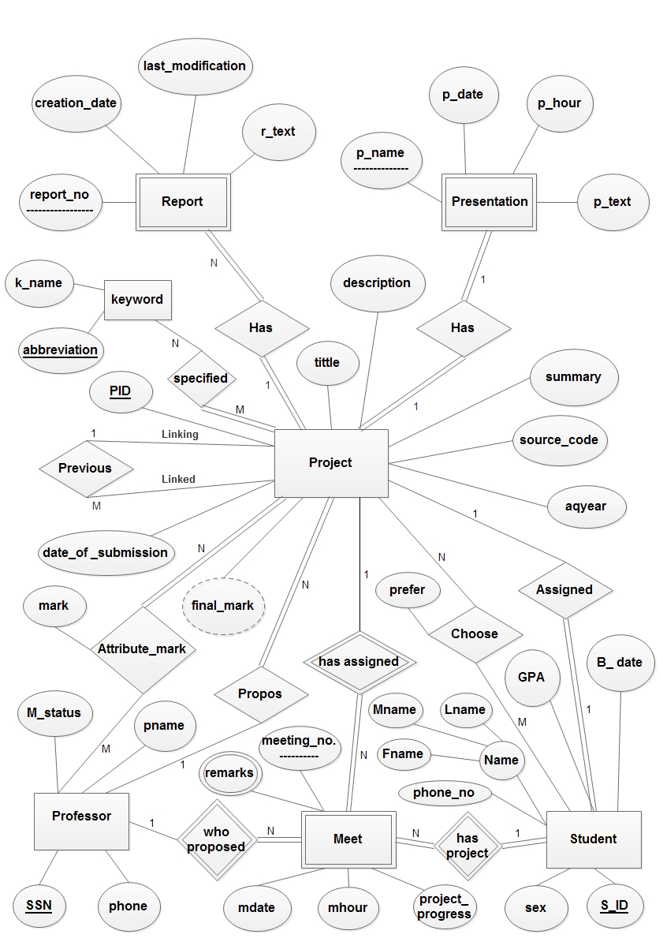

1. **Relational model**

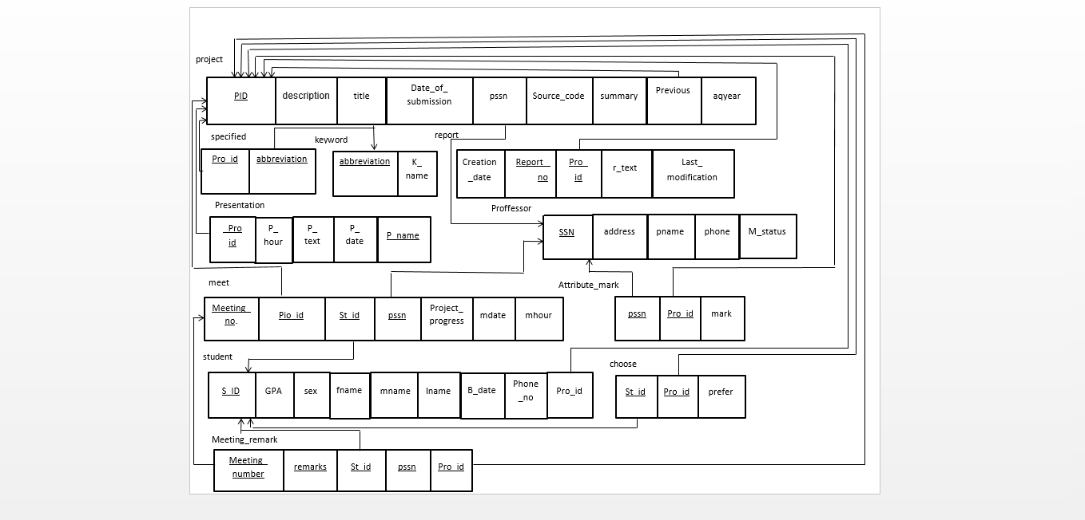

Part 2: Database Design

1. **Database definition**

In the text

1. **Sample of data**

In the text .

1. **Queries**

In the text .

1. **Conclusion**

We made a database for tracking graduation projects , we made an ER model to show the relations between professors , students , projects … etc

And then we mapping it to relational model consists of tuples and arrows to show relations.

Then we make a SQL commands to create this database in Oracle and insert some information in the tuples and finally answer the Queries.